PDC LAB FINAL
Zubair Naeem
SP23-BAI-057

GRPC:
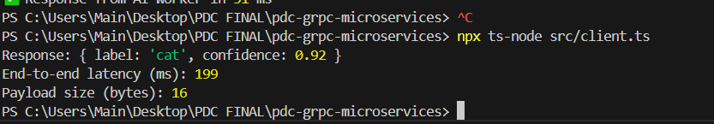
On server: 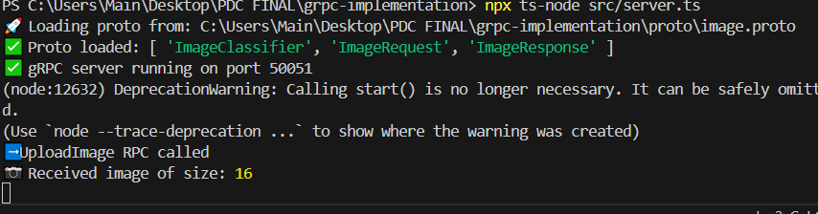

Microservices grpc architecture:
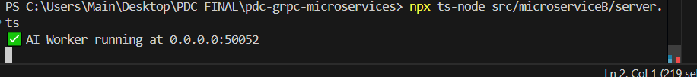
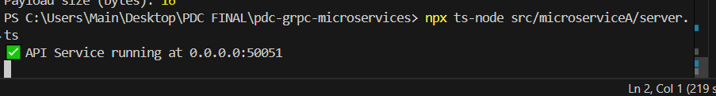
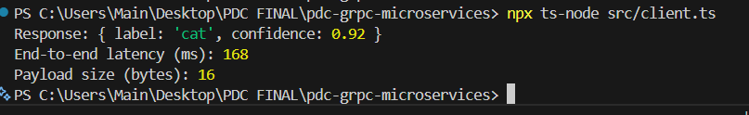
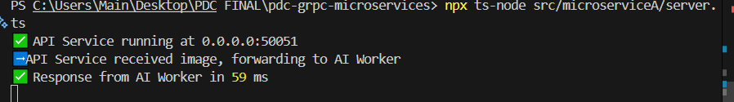
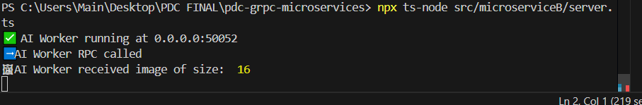
TRCP:
